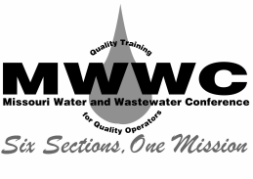
Missouri Water and Wastewater Confernce
P.O. Box 14170
Springfield, MO 65814
Telephone 573/657-0266
www.mwwc.net

Associate Membership Application

Please complete this form as fully and accurately as possible so that we might better serve you.

_______________________________________________________________________________
Company Name Contact Person

_______________________________________________________________________________
Mailing Address

_______________________________________________________________________________
Billing Address

_______________________________________________________________________________
City State Zip Code County

_______________________________________________________________________________
Business Phone E-mail Address

Website: __________________________________________________

Please make $85.00 Checks Payable to the MWWC and mail with this application to:

Leslie Miller
P.O. Box 14170
Springfield, MO 65814

Method of Payment:
Bill My Employer For Payment in Full Bill Me For Payment in Full

